Member Card
MVP

Contents

The design 3
Common instructions 3
Mobile application 3
Code quality 3
3rd parties and licenses 4
Screens 5
- Loading/Splash Screen 5
- Home Screen 6
- Search results screen 7
- Category Screen 7
- Item Screen 9
Main Components 10
JSON 12

MemberCard project is a web mobile application that offers a membership and exposes product catalogs / advertisements to enrich the engagement between the business and its customers.

The design
Use the web side-menu version - http://zara.com - but the animation should be slower, in the example it is opening fast ( https://drive.google.com/open?id=1r8Ic-U7EXd8xZqeMab7Y6S93d3_Zql0w ). Only category and one subcategory will be implemented.
Regarding the design - try to make it like Zara.
The animations and hovers - should be the same as much as possible like in Zara’s app.
https://drive.google.com/open?id=18EKxyhDuIQfJHiMIUt4HxeMXmodTj2A9
All the animations (and layouts)
Tablet view - https://drive.google.com/open?id=1V7AT93gwmWHzT0jnUnJ_4-qj-a5ueK5b
Phone view - https://drive.google.com/open?id=1ppeww4Y9sCZdTYl3QUbN0cqHEWNm5tN8

Common instructions
This section is describing all common instructions and requirements for all the screens.

Mobile application
The provided screens are for mobile application and it need to be responsive and tested in both Android and IOS devices. It need to support different mobile screens sizes.
Type of input elements: it’s important to use correct type like phone, or number keyboard.
Validation: it’s import to perform input validation.
….
technologies required:
1- Angular 2/4/5
2- Twitter Bootstrap
3- HTML5
4- CSS
5- Cordova
6- jHipster

Code quality
The provided code need to be clean, Professional, Maintainable which allow easily to be modified and customized.

3rd parties and licenses
The application is a commercial application and need to make sure not to use LGPL or other 3rd parties, resources, code or reuse which will limit our license.
Also not to use other which are not free.

Screens

Loading/Splash Screen
Will display splash image - logo on the middle of the screen and loading spinner below it (loading icon)

Home Screen
This is the main screen displays the stores advertisements and catalogs and navigates to the other screens.
Screenshots Samples
1
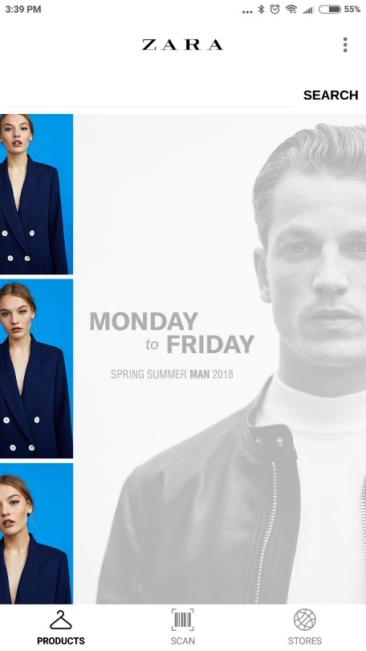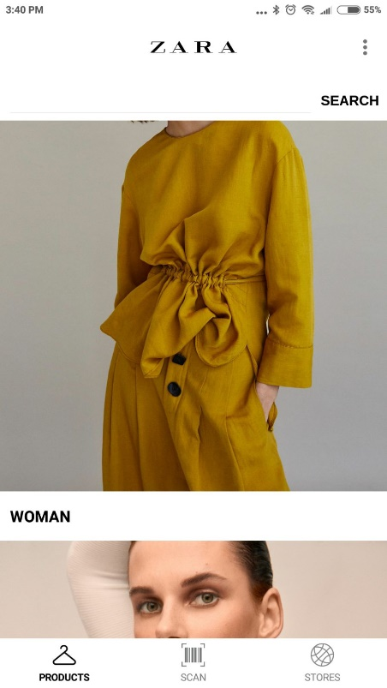
5
4
3
2
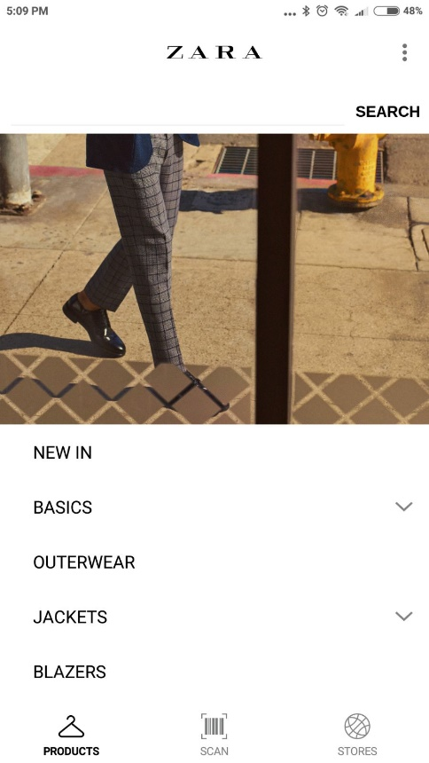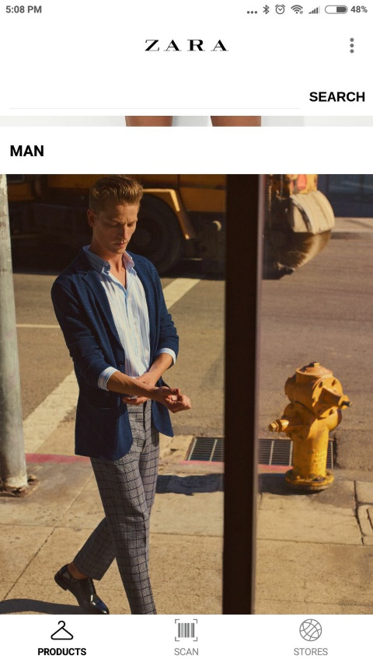
6
8
7

Search results screen
Should be implemented search results screen. Search should work on the frontend only. Will search item component and category components. Search will work for itemName and categoryName
Implement “lazy load” for that possibility. There would be only about 100 pictures at the beginning.
In Zara’s app categories presented for tablets in this screen. We don’t need to implement that.

Category Screen
Items should be scrolled infinitive.

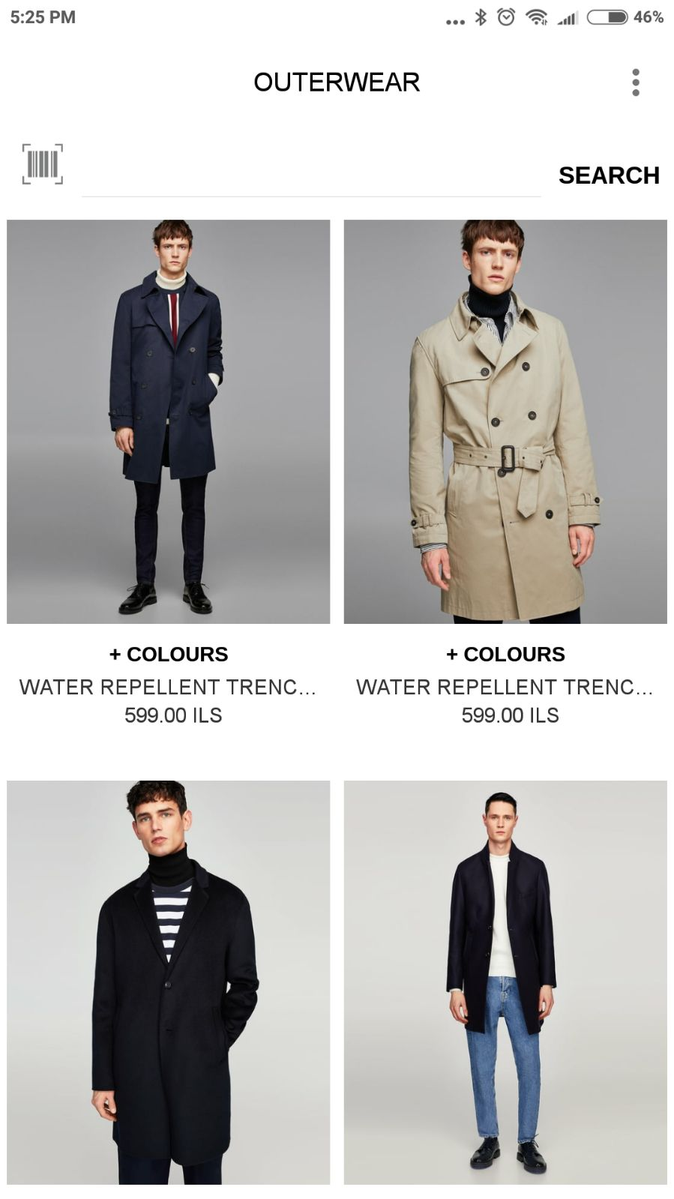
9

Item Screen

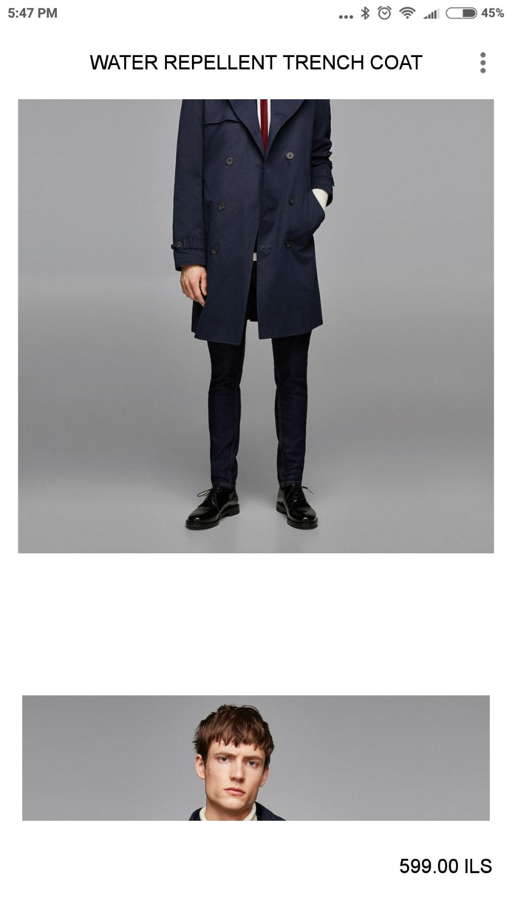
10

Main Components
Component Name | Description | Input | Index
HomeComponent | Main screen component which display:  - HeaderComponent  - SearchComponent  - CarouselCompomemt  - SectionsComponent (list)  - FooterComponent
HeaderComponent | Will display icon or text with option to control the style like text font size and the icon size…  to reuse same component for all screens. | Text  Icon  Style for the text/Icon  If displayLogo is true we should display logo image  http://joxi.ru/krD43qMt0eoElr | 1
SearchComponent | Should search through CategoryName and ItemName | Text
SearchResultsComponent | Should display results of the SearchComponent. | Text
CarouselComponent | Circular auto display of images (animated)  Manual left/right navigation  Clickable images  List of ItemComponent | Control auto scroll time in seconds  Style | 3
SectionListComponent | Contains one or more SectionComponent |  | [4,8]
SectionComponent | Contains title, Collapsible list of CategoryComponent – (closed by default) |  | 8
CategoryComponent | Contains title and list of ItemComponent.  Each row displays 2 items |  | 9
ItemComponent | Contains title and list of Images and description (price/available sizes/available colors).  Each row displays 1 Image only |  | 10
FooterComponent | Contains 2 icons:  - Facebook icon – redirect to the store page in Facebook application or default browser in case Facebook is not installed.  - My Account icon – disabled for now. |  | 5

JSON

